
Learning and Teaching Unit

MPU3193/mpu3192
PHILOSOPHY AND CURRENT ISSUES
Semester 1/ 2

Assignment Information Pack

Information about this assessment:
- Release date: Week 1
- Marks allocation: This assessment accounts for 50% of the total marks available for this unit, in the following promotions:
  - Group Report (E-Portfolio): 30%
  - Group Presentation (Virtual Presentation): 20%
- Submission due for Group Report (E-Portfolio): Sunday, Week 13
- Virtual Presentation: Week 10 – 11
- Submission due of report for Virtual Presentation (Report): Sunday, Week 13




Swinburne University of Technology recognises the historical and cultural significance of Australia’s Indigenous history and the role it plays in contemporary education

We therefore acknowledge the traditional custodians of the land that our Australian campuses currently occupy, the Wurundjeri people, and pay respect to Elders past and present, including those from other areas who now reside on Wurundjeri land

PART 1 Instructions and General Information

Marks allocation and assessment components
This assessment accounts for 50% of the total marks available for this unit; and is divided into the following components:
- Group Project: 30% of the total marks available for this unit
- Virtual Presentation: 20% of the total marks available for this unit.

Group Project (30%)
Objective:
Embark on a transformative learning journey as you explore diverse philosophies and contemporary challenges both within Malaysia and on the global stage. This assignment is designed to cultivate a profound understanding of various perspectives while addressing real-world issues through the United Nations Sustainable Development Goals (SDGs) lens.

Task Overview:
Within your group, engage in extensive research to identify and delve into a current issue that aligns with one of the United Nations' SDGs. Your objective is not only to comprehend the complexities of the chosen issue but also to synthesize your insights into a comprehensive report. Additionally, your group will be responsible for conveying your findings with impact through a compelling video presentation.

Assignment Details:
- Form a group of 10 students to work with by the beginning of Week 2.
- Your task is to choose one of the Sustainable Development Goals (SDGs) outlined by the United Nations and investigate a current issue related to that goal. Through this assignment, you will delve into the intricacies of the selected issue, analyze its contributing factors and implications, propose viable solutions, discuss several cases related to the issues, establish connections with topics covered in lectures, and draw meaningful conclusions.
- Link to know more about SDGs: https://sdgs.un.org/goals#history
- Your issues must be linked to the SDGs as stated below:

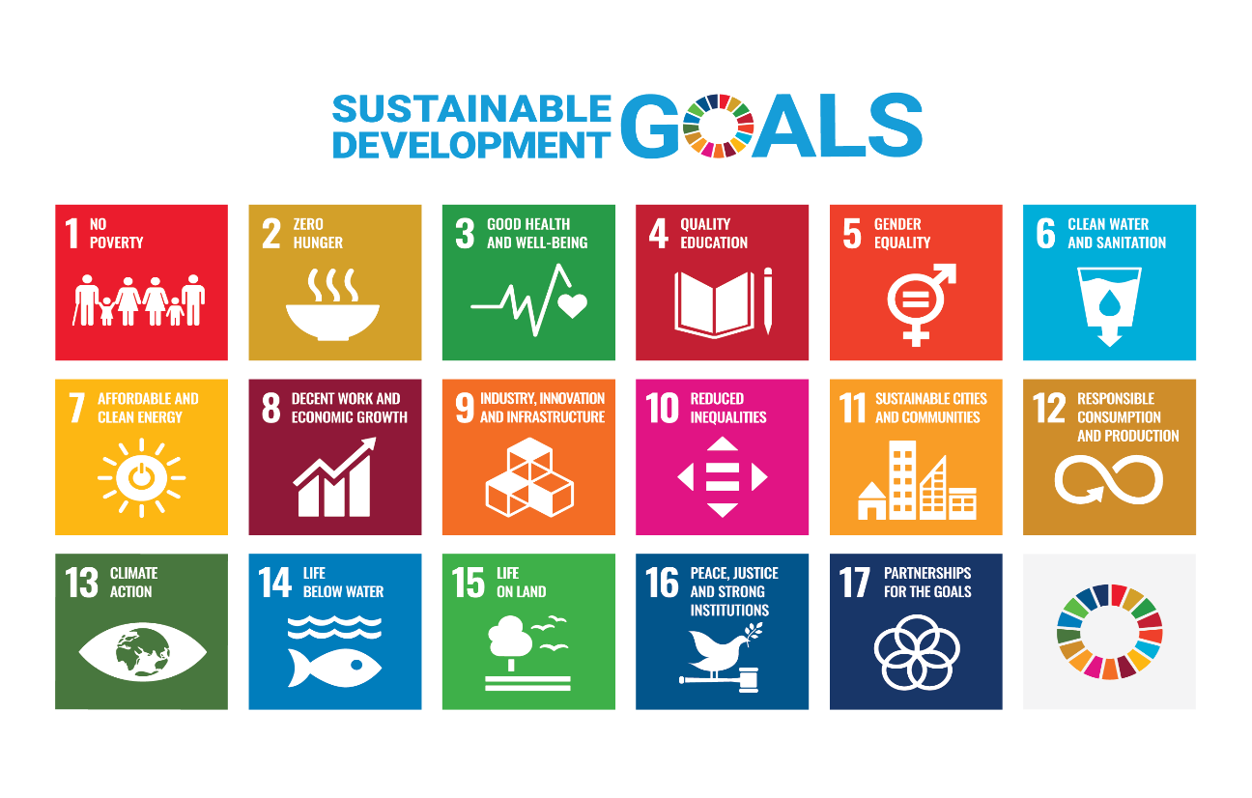
- Based on your selection above, your group must produce an e-portfolio using the WIX platform (www.wix.com ).

Content of your e-portfolio
- Main Page: (Home Page)
The main page includes welcoming note, a video of the project, name of the chosen SDG, and details of the group. Add pictures related to the topic.
- Students’ Profile: (About Us Page)
Your group profile includes individual information (profile picture, name, study program, origin, etc.) and tasks given to them or completed by them.
- Introduction: (Home Page)
Introduce the selected SDG, briefly outline its objectives, and explain why you chose your selected SDG.
- 5 Selected Cases (Case Study Page)
Select five popular/viral cases that are related to your selected SDG and write a summary of those five cases individually. In your summary, you may include any pictures, videos, newspaper cutting, or extra links that relate to your selected cases.
- Factors of the Issue: (Case Study Page?)
Analyze and discuss the key factors contributing to the selected cases. Consider social, economic, environmental, and political aspects that influence the issue.
- Implication of the Issues: (Case Study Page?)
Analyze the implications of the issue on society, country, and global citizens.
- Solutions: (Case Study Page?)
Propose viable and sustainable solutions to address the selected cases. Discuss the potential impact of these solutions and how they align with the principles of the chosen SDG.
- Connection with Lecture Topics: (Case Study Page?)
Relate the selected cases to concepts discussed during lectures. Highlight any theories, philosophical thinking, or concepts covered in class that are relevant to your chosen issue (Minimum 3 main points).
- Individual Reflections (About Us Page)
Write what you have learned through this assignment. The reflection is a cumulative learning experience that you gained based on 3 Domains of Learning: Cognitive, Affective, and Psychomotor. For this section, you need to write your full name and insert your picture next to your reflection.
- Social Media Campaign (Social Media Page)
You have to share proof of your social media campaign by giving pictures of your online campaign activities, including sharing on social media platforms, views, engagements, comments, etc. Kindly refer to the next section to learn more about Social Media Campaigns.
- Conclusion: (Home Page)
Summarize the key findings and insights from this project. Emphasize the importance of addressing the current issue within the context of sustainable development and philosophical theories and thinking.

- References (Others)
List down your source of references according to APA Style 7th Edition.
- Appendixes (Others)
Attach/share pictures or proofs of the progress of finishing your assignment. You may share some pictures of your group meetings, online conversations, field trips, etc.

- Observe the following guidelines in completing your e-portfolio:
  - Your e-portfolio must provide a thorough analysis of your selected topic. The accuracy of information is extremely important while writing your e-portfolio.
  - All the points should be well-linked. There should be cohesion within and between paragraphs. Use linking words (such as firstly, in addition, to sum up) to help you.
  - You may include illustrations/pictures/graphs in your report.
- To learn more about the WIX platform, kindly watch the following video:
https://www.youtube.com/watch?v=b9vUty54mZI
- Example of e-portfolio:
https://hubunganetnik7.wixsite.com/kawanz ; https://mputaylors.wixsite.com/mputaylors/program
https://sapphiremalik7.wixsite.com/mysite
- Example of video (short drama):
https://www.youtube.com/watch?v=asjCsa7xUuw&t=58s

Virtual Presentation (20%)

- Virtual Presentation will be conducted two phases as follows:
  - Social Media Campaign (Week 9 & 10)
  - Virtual Presentation on Module Site (Canvas) (Week 11)
- To complete this task, students need to prepare a video as follows:
- Video Duration: Minimum 5 minutes and maximum 10 minutes
- Language: English; however, other languages may be used to a minimum extent depending on the situation. English subtitles should accompany the video.
- Video Format: Students can use their own creativity, but they cannot use Zoom, TEAMS, or PowerPoint. Video formats include news, role plays, documentaries, analyses, travel logs, and others.
- Format: MP4, landscape format, clear audio quality, good video quality.
- There is no fixed format for video content; however, the video must educate people about your selected SDG/issue. Hence, your video content is based on your creativity in raising awareness about your selected SDG.
- The Social Media Campaign must be conducted in week 9-10 as stated below:
- The video produced should be uploaded to students' social media accounts, such as Facebook, Instagram, and TikTok. Using reels or FB stories is discouraged because the content/submission is not permanent on social media.
- Use creative caption when you share your video on social media and consider using this hashtag: #swinburnesarawak #SDGs #MPUswinburnesarawak
- All group members must share/post the video submission link on their respective social media platforms to achieve high engagement, including comments, likes, and shares.

- Virtual presentation on Module Site (Canvas) will occur in week 11 as stated below:
- Each group must share the submission/link in the "Virtual Presentation" section within the Canvas/Module site. Each group only shares one submission.
- Each group must provide comments in the form of reviews/comments/suggestions for videos shared by other groups. The minimum number of comments to be given is 10 submissions (1 submission for one group), with a minimum of 50 words for each submission.
- Your group is responsible for replying to any comments/questions/inquiries posted by other group members.
- Submission of evidence for the Virtual Presentation will take place in week 13, and the content of your submission will be as follows:
- Assignment Cover Sheet
- Table of contents
- c. Evidence of the social media campaign is shown through screenshots showing the number of likes, shares, comments (engagement), and the campaign link on social media. (These can be the same materials from your e-portfolio.)
- Evidence of your comments in Canvas regarding other group videos.
- Reflections – A group reflection on what you learned through the Virtual Presentation task (Minimum 350 words).
- Appendices: Picture of your group meetings, shooting or online discussions to complete this task.

Group Assignment Timelime: Timeline

- Week 1 & 2: Assignment Briefing and Grouping
- Week 3 & 4: Develop content and e-portfolio
- Week 4 & 5: Develop video storyline content e-portfolio consultation with lecturer
- Week 6 – 8: Video production & enhance content and e-portfolio
- Week 9 & 10: Social media campaign & enhance e-portfolio
- Week 11: Virtual presentation via Canvas
- Week 13: Submission of e-portfolio & Report of Virtual Presentation

PART 2 Marking Criteria

Marking rubric – e-Portfolio

criteria | Excellent (5-6 points) | Good (3-4 points) | Satisfactory (1-2 points) | Needs Improvement (0 points)
Content & Reflection | Comprehensive and insightful reflections on learning experiences; all required components included with deep analysis. | Adequate reflection on most learning experiences; most components are included and analyzed. | Brief reflection with minimal analysis; some required components are missing or underdeveloped. | Minimal or no reflection on learning experiences; several key components are missing.
Organization & Structure | Clear, logical structure with excellent flow and easy navigation between sections. | Well-organized with smooth transitions, though some sections could improve. | Some structure, but sections may feel disjointed or hard to navigate. | Lacks organization, making the e-portfolio difficult to follow or navigate.
Visual Design & Creativity | Highly engaging, creative, and visually appealing design that enhances content. | Visually appealing with some creative elements that support the content. | Basic design with minimal creativity; some visual appeal but does not enhance the content. | Poor design with little to no creativity; visuals detract from the content.
Collaboration & Group Effort | Excellent group collaboration; all members contribute meaningfully and the work is cohesive. | Good group collaboration, with most members contributing effectively. | Some collaboration, but uneven contributions from members; work lacks full cohesion. | Minimal collaboration; uneven member contributions and a lack of cohesion in the final product.
Technical Competence | e-Portfolio is free of technical errors (e.g., broken links, formatting issues); all multimedia elements function smoothly. | Minor technical errors that do not significantly detract from the overall experience. | Some technical errors that affect the functionality or appearance of the e-portfolio. | Multiple technical issues that hinder functionality and user experience significantly.

Marking rubric – Virtual Presentation
Criteria Task description |  | Full PoorMarks Fair Good
 |  | Full Poor Fair Good
Introduction | - Clear identification of the topics to be addressed. | 2.5 | 0.0 – 1.0 | 1.1 – 2.0 | 2.1 – 2.5
Audio visual | Aids or visuals are clear, appropriate, visible to the audience, helping to make ideas/concepts tangible.  - Aids or visual in video appropriate  - Have multiple illustrations/pictures/video clips/ other resources | 3.5 | 0.0 – 1.0 | 1.0 – 2.5 | 2.6 – 3.5
Synergy | - A unified approach and good management of audio, visual  / aids.  - Linking contents between presenters. | 2.0 | 0.0 – 0.5 | 0.6 – 1.5 | 1.6 – 2.0
Attire | - Is the presenter dressed appropriately? | 2.5 | 0.0 – 1.0 | 1.1 – 2.0 | 2.1 – 2.5
Speaking style | - Do the presenter use an appropriate pace?  - Do the presenter use appropriate body language (e.g. hand gesture, etc.)?  - Is the presenter’s voice clear? | 2.5 | 0.0 – 1.0 | 1.0 – 2.0 | 2.1 – 2.5
Language and pitch | - Is the language used appropriate to the audience?  - Are the words pronounced correctly? | 2.0 | 0.0 – 0.5 | 0.6 – 1.5 | 1.6 – 2.0
Organization | - Is there strong evidence to support the main points with illustrations?  - Is the information structured, linked and well-planned? | 3.0 | 0.0 – 1.0 | 1.0 – 2.0 | 2.1 – 3.0
Closing | - Summarize all key points. | 2.0 | 0.0 – 0.5 | 0.6 – 1.5 | 1.6 – 2.0
Total |  | 20.0

PART 3 Inquiry

For any inquiries, kindly contact your lecturer:

 | Dr. Serit anak Banyan  Lecturer cum MPU Coordinator Learning and Teaching Unit  Swinburne University of Technology Sarawak Campus Jalan Simpang Tiga, 93350 Kuching, Sarawak, Malaysia Q: 082-2607852 (Office)  Email: sbanyan@swinburne.edu.my https://www.swinburne.edu.my/staff/serit_anak_banyan.php

